Angular project

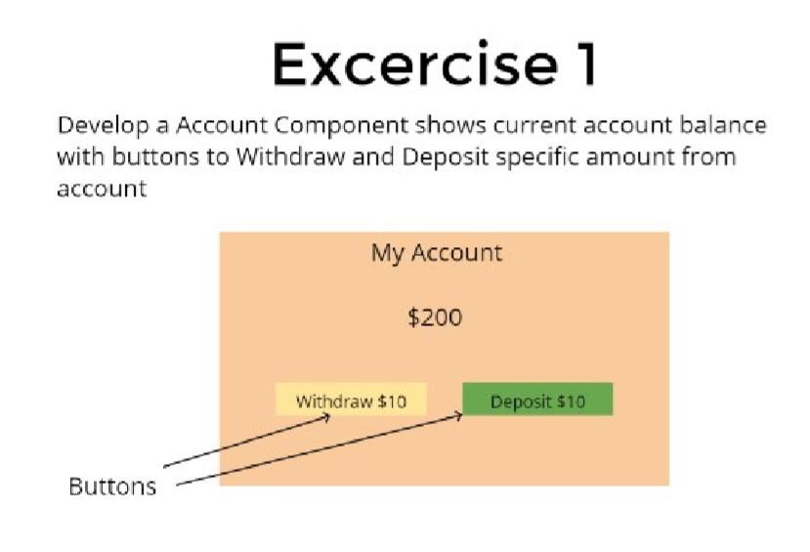

import { Component } from '@angular/core';

@Component({

selector: 'app-root',

template: `

<div class="app">

<h1> {{name}} </h1>

<h2>$ {{amount}} </h2>

<button (click)="handleClick2($event)" [disabled]='c' class="app2">Withdraw $10</button>

<button (click)="handleClick1($event)" class="app1">Deposit $10 </button>

</div>

`,

styleUrls: ['./app.component.scss']

})

export class AppComponent {

name:string;

amount:number=200;

c:string;

constructor(){

this.name="My Account";

}

handleClick2(event: any){

if(this.amount==10)

this.c="disabled";

this.amount=this.amount-10;

}

handleClick1(event: any){

if(this.amount>=0)

this.c="";

this.amount=this.amount+10;

}

}

.app{

text-align: center;

background-color: rgb(247, 212, 199);

background-size: 10px;

padding: 20px;

display: inline-block;

margin-left: 525px;

}

.app1{

background-color: rgb(245, 237, 165);

text-align: center;

margin: 5px;

}

.app2{

background-color:rgb(153, 248, 153);

text-align: center;

margin: 5px;

}

PS F:\angularproject\Exercise1> cd exercise1

PS F:\angularproject\Exercise1\exercise1> npm start

> exercise1@0.0.0 start F:\angularproject\Exercise1\exercise1

> ng serve

localhost:4300

o/p:

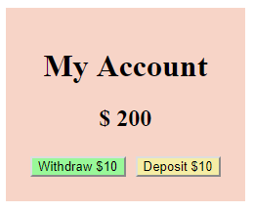

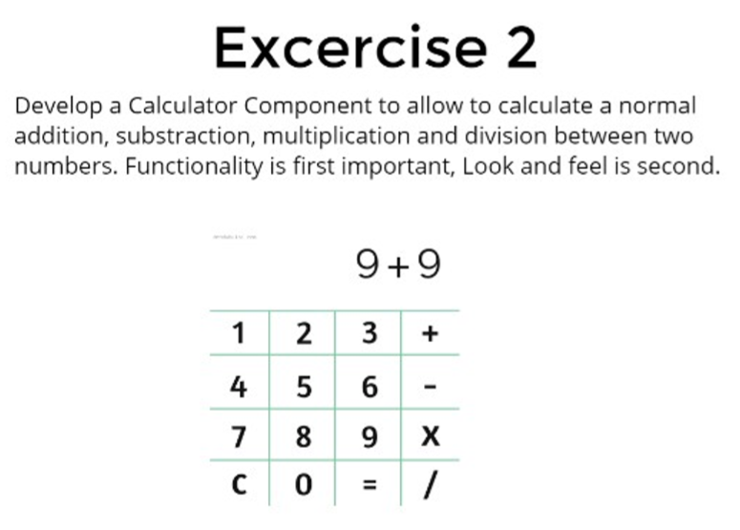

<html>

<body>

<h1> Calculator </h1>

<div>

<tr>

<span *ngIf="n1!=0">{{n1}}</span>

<span *ngIf="n1!=0">{{op}}</span>

<span *ngIf="n2!=0">{{n2}}</span>

<span *ngIf="result!=0">={{result}}</span>

</tr>

</div><br>

<table>

<tr>

<td><input type="button" value="1" (click)="add1($event)"></td>

<td><input type="button" value="2" (click)="add2($event)"></td>

<td><input type="button" value="3" (click)="add3($event)"></td>

<td><input type="button" value="+" (click)="plus($event)"></td>

</tr>

<tr>

<td><input type="button" value="4" (click)="add4($event)"></td>

<td><input type="button" value="5" (click)="add5($event)"></td>

<td><input type="button" value="6" (click)="add6($event)"></td>

<td><input type="button" value="-" (click)="minus($event)"></td>

</tr>

<tr>

<td><input type="button" value="7" (click)="add7($event)"></td>

<td><input type="button" value="8" (click)="add8($event)"></td>

<td><input type="button" value="9" (click)="add9($event)"></td>

<td><input type="button" value="x" (click)="mul($event)"></td>

</tr>

<tr>

<td><input type="button" value="C" (click)="clear($event)"></td>

<td><input type="button" value="0" (click)="add0($event)"></td>

<td><input type="button" value="=" (click)="equal($event)"></td>

<td><input type="button" value="/" (click)="div($event)"></td>

</tr>

</table>

</body>

</html>

import { Component } from '@angular/core';

@Component({

selector: 'app-root',

templateUrl: './app.component.html',

styleUrls: ['./app.component.scss']

})

export class AppComponent {

n1:number=0;

n2:number=0;

op:string;

result:number=0;

flag:number=0;

add0(){

if(this.flag==0)

return this.n1=this.n1+0;

else

return this.n2=this.n2+0;

}

add1(){

if(this.flag==0)

return this.n1=this.n1*10+1;

else

return this.n2=this.n2*10+1;

}

add2(){

if(this.flag==0)

return this.n1=this.n1*10+2;

else

return this.n2=this.n2*10+2;

}

add3(){

if(this.flag==0)

return this.n1=this.n1*10+3;

else

return this.n2=this.n2*10+3;

}

add4(){

if(this.flag==0)

return this.n1=this.n1*10+4;

else

return this.n2=this.n2*10+4;

}

add5(){

if(this.flag==0)

return this.n1=this.n1*10+5;

else

return this.n2=this.n2*10+5;

}

add6(){

if(this.flag==0)

return this.n1=this.n1*10+6;

else

return this.n2=this.n2*10+6;

}

add7(){

if(this.flag==0)

return this.n1=this.n1*10+7;

else

return this.n2=this.n2*10+7;

}

add8(){

if(this.flag==0)

return this.n1=this.n1*10+8;

else

return this.n2=this.n2*10+8;

}

add9(){

if(this.flag==0)

return this.n1=this.n1*10+9;

else

return this.n2=this.n2*10+9;

}

plus(){

this.flag=1;

this.op='+';

}

minus(){

this.flag=1;

this.op='-';

}

mul(){

this.flag=1;

this.op='*';

}

div(){

this.flag=1;

this.op='/';

}

equal(){

if(this.op=="+"){

this.result=this.n1+this.n2;

return this.result;

}

else if(this.op=="-")

{

this.result=this.n1-this.n2;

return this.result;

}

else if(this.op=="*")

{

this.result=this.n1*this.n2;

return this.result;

}

else if(this.op=="/")

{

this.result=this.n1/this.n2;

return this.result;

}

}

clear(){

this.flag=0;

this.op="";

this.n1=0;

this.n2=0;

this.result=0;

}

}

body{

text-align: center;

font-size:15px;

}

table{

border-collapse: collapse;

text-align: center;

margin-left: 575px;

}

table, td, th{

border-style: solid;

border-color:aqua;

padding: 10px;

border-spacing: 2px;

}

div{

background-color:rgb(238, 103, 125);

//border-block-color: red;

height:66px;

width: 200px;

margin-left:575px;

text-align: center;

}

h1{

font-size:45px;

}

span{

text-align: right;

font-size:40px;

}

PS F:\angularproject\Exercise2> cd exercise2

PS F:\angularproject\Exercise2\exercise2> npm start

> exercise2@0.0.0 start F:\angularproject\Exercise2\exercise2

> ng serve

localhost:4400

o/p:

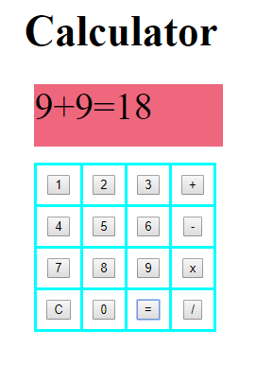

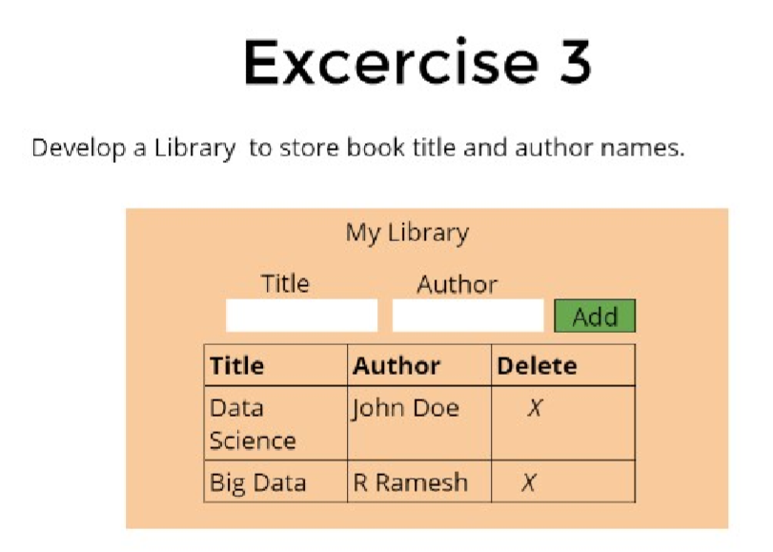

<html>

<body>

<div>

<h1> My Library</h1>

<span>Title</span>

<span>Author</span><br>

<input type="text" (keyup)="input1($event)">

<input type="text" (keyup)="input2($event)">

<button (click)="add($event)"> Add </button><br><br>

</div>

<div>

<table>

<tr>

<th> Title </th>

<th> Author </th>

<th> Delete </th>

</tr>

<tr>

<td> Data Science </td>

<td> John Doe </td>

<td> X </td>

</tr>

<tr>

<td> Big Data </td>

<td> R Ramesh </td>

<td> X </td>

</tr>

<tr *ngFor="let row of rows">

<td> {{ row.Title }}</td>

<td> {{ row.Author }}</td>

<td> {{ row.Delete }}</td>

</tr>

</table>

</div>

</body>

</html>

import { Component } from '@angular/core';

@Component({

selector: 'app-root',

templateUrl: './app.component.html',

styleUrls: ['./app.component.scss']

})

export class AppComponent {

T:string;

A:string;

Del:string="X";

rows=[];

input1(event){

this.T=event.target.value;

return this.T;

}

input2(event){

this.A=event.target.value;

return this.A;

}

add(){

this.rows.push( {Title: this.T, Author: this.A, Delete:this.Del} );

}

}

body{

background-color: hotpink;

text-align: center;

width: 400px;

margin-left:30%;

border-radius: 5px;

}

span{

text-align: center;

margin:35px;;

}

input{

margin:5px;

background-color: white;

width: 35%;

}

h1, div{

text-align: center;

}

table, th, td {

border: 1px solid black;

text-align: center;

margin-right: 475px;

}

table {

border-collapse: collapse;

width: 250px;

text-align: center;

height: 50px;

margin-left:20%;

}

th {

height: 40px;

}

button{

background-color: rgb(65, 145, 65);

}

S F:\angularproject\Exercise3> cd exercise3

PS F:\angularproject\Exercise3\exercise3> npm start

> exercise3@0.0.0 start F:\angularproject\Exercise3\exercise3

> ng serve

localhost:4500

o/p:

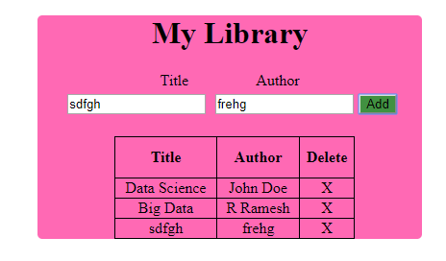

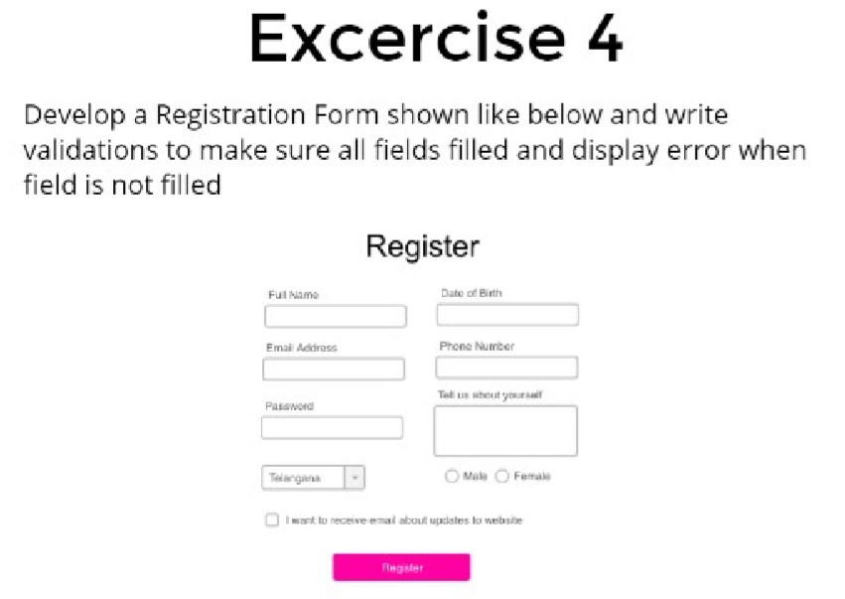

<html>

<body>

<h1> Register </h1>

<table>

<tr>

<td> Full Name </td>

<td> Date of Birth </td>

</tr>

<tr>

<td><input type="text" (keyup)="name($event)" required></td>

<td><input type="date" (keyup)="DOB($event)" required></td>

</tr><br>

<tr>

<td> Email Address </td>

<td> Phone Number </td>

</tr>

<tr>

<td><input type="email" (keyup)="email($event)"required></td>

<td><input type="text" (keyup)="phone($event)"required></td>

</tr><br>

<tr>

<td> Password </td>

<td> Tell us About Yourself</td>

</tr>

<tr>

<td><input type="password" (keyup)="password($event)" required></td>

<td><textarea rows="3" cols="22" ></textarea></td>

</tr><br>

<tr>

<select name="state" (click)="sta($event)" required>

<option value="">select state</option>

<option value="Andhrapradesh"> Andhrapradesh </option>

<option value="Telangana"> Telangana </option>

<option value="Orissa"> Orissa </option>

<option value="Tamilnadu"> Tamilnadu </option>

</select>

<td><input type="radio" name="gender" value="Male" (click)="gen($event)"required>Male<br>

<input type="radio" name="gender" value="Female" (click)="gen($event)"required>Female</td>

</tr><br>

<tr>

<input type="checkbox" (click)="check($event)" required>I want to receive email about updates to website<br>

</tr><br>

<tr>

<button (click)="add($event)"> Register </button>

</tr>

</table>

</body>

</html>

import { Component } from '@angular/core';

@Component({

selector: 'app-root',

templateUrl: './app.component.html',

styleUrls: ['./app.component.scss']

})

export class AppComponent {

a:string;

c:string;

e:string;

g:number;

i:string;

k:boolean=false;

m:boolean=false;

o:boolean=false;

name(b:any){

this.a=b.target.value;

}

DOB(d:any){

this.c=d.target.value;

}

email(f:any){

this.e=f.target.value;

}

phone(h:any){

this.g=h.target.value;

}

password(j:any){

this.i=j.target.value;

}

sta(l:any){

this.k=true;

}

gen(n:any){

this.m=true;

}

check(p){

this.o=true;

}

add(){

if( this.a!="" && this.c!=null && this.e!="" && this.g!=null && this.m!=null && this.i!=null && this.k==true && this.m==true && this.o==true )

{

alert("registration successfull");

}

else

{

alert("fill out all the fields");

}

}

}

h1{

text-align: center;

}

table{

margin-left: 450px;

}

button{

margin-left:250px;

background-color: rgb(236, 4, 147);

}

S F:\angularproject\Exercise4> cd exercise4

PS F:\angularproject\Exercise4\exercise4> npm start> exercise4@0.0.0 start F:\angularproject\Exercise4\exercise4> ng serve >localhost:4600

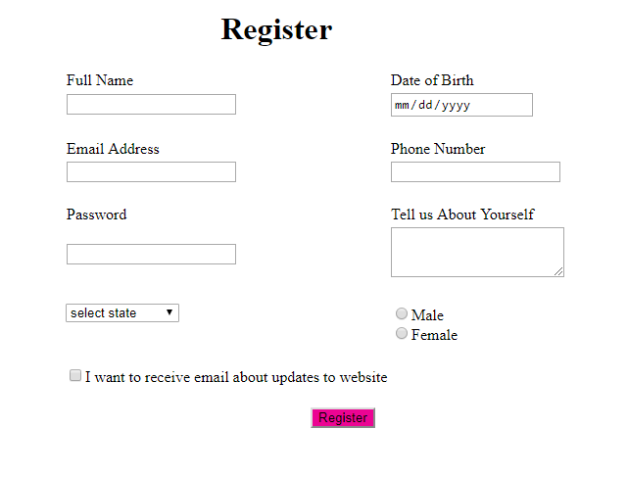

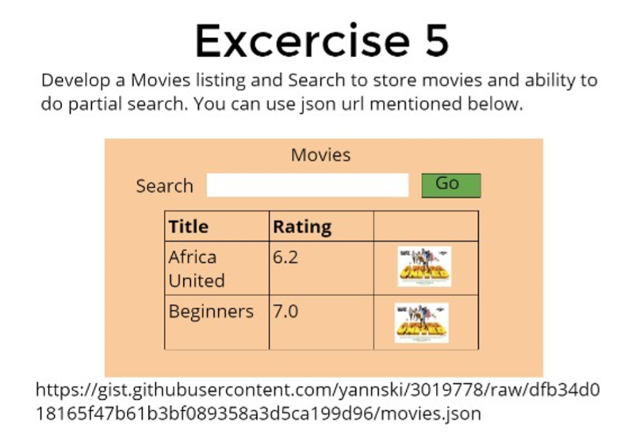

<html>

<body>

<span> <b> Movies </b> </span><br>

<span> Search </span>

<input type="text" (input)="add($event)">

<button (click)="but($event)"> Go </button>

<table>

<tr>

<th> Title </th>

<th> Rating </th>

</tr>

<tr *ngFor="let film of movie">

<td>{{ film.title }}</td>

<td>{{ film.rating }}</td>

</tr>

</table>

</body>

</html>

import { Component } from '@angular/core';

import { Movie } from './models/movie.interface';

@Component({

selector: 'app-root',

templateUrl: './app.component.html',

styleUrls: ['./app.component.scss']

})

export class AppComponent {

movies:Movie[] = [{"id":"4fede17c312f912796000034","cover_url":null,"description":null,"rating":6.3,"title":"L'affaire Gordji, histoire d'une cohabitation"},{"id":"4fede17f312f912796000035","cover_url":null,"description":"Documentary telling the true story of the sinking of the liner Laconia by a German U-boat in 1942 through the eyes of six survivors.","rating":6.8,"title":"Le naufrage du Laconia - partie 1"}, {"id":"4fede66a312f9127960002f3","cover_url":"http://ia.media-imdb.com/images/M/MV5BMTMwNTEyMTE1NV5BMl5BanBnXkFtZTcwNjI1NDA3NA@@._V1._SX94_SY140_.jpg","description":"When a solar eclipse sends a colossal blast of super chilled air towards the earth, it then sets off a catastrophic chain of events that threatens to engulf the world in ice and begin a new Ice Age.","rating":3.7,"title":"MENACE DE GLACE"}];

title1:string;

movie:Movie[] = [];

constructor(){

this.title1="";

}

add(event:any){

this.title1=event.target.value;

}

but(){

this.movie=this.movies.filter((movie)=>{

return movie.title.includes(this.title1)==true;

})

console.log(this.movie)

}

}

export interface Movie{

id:string;

cover_url:string | null;

description:string | null;

rating:number;

title:string;

}

body{

text-align: center;

font-size: 20px;

background-color: rgb(245, 192, 127);

display:inline-block;

margin-left: 480px;

height: 40%;

width: 30%;

}

input{

margin: 10px;

}

button{

background-color: rgb(55, 165, 55);

}

table, th,td{

border: 1px solid black;

border-collapse: collapse;

margin-left: 25%;

width: 50%;

padding:7px;

}

th{

text-align: center;

}

PS F:\angularproject\Exercise5> cd exercise5

PS F:\angularproject\Exercise5\exercise5> npm start

> exercise5@0.0.0 start F:\angularproject\Exercise5\exercise5

> ng serve

localhost:4700

o/p:

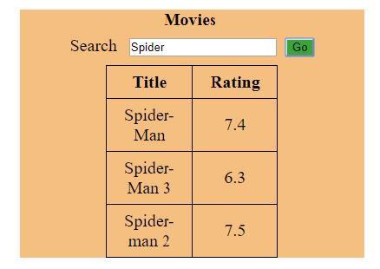

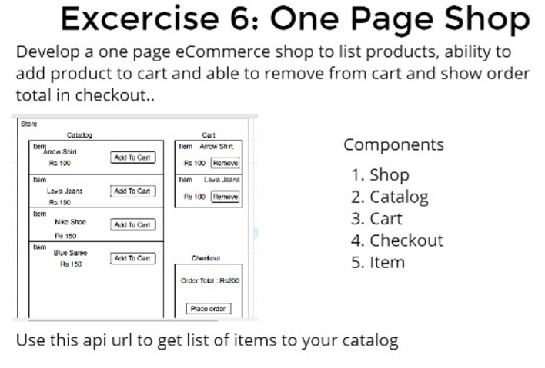

<html>

<body>

<div class="main" >

<caption> <h1>Store</h1> </caption>

<div class="left">

<table>

<caption> Catalog </caption>

<tr>

<td> item: <br> {{arr[0]}} <button (click)='itemlist(0)'> Add to Cart </button><br> Rs {{rs[0]}} </td>

</tr>

<tr>

<td> item: <br> {{arr[1]}} <button (click)='itemlist(1)'> Add to Cart </button> <br> Rs {{rs[1]}}</td>

</tr>

<tr>

<td> item: <br> {{arr[2]}} <button (click)='itemlist(2)'> Add to cart </button><br> Rs {{rs[2]}}</td>

</tr>

<tr>

<td> item: <br> {{arr[3]}} <button (click)='itemlist(3)'> Add to Cart </button><br> Rs {{rs[3]}}</td>

</tr>

</table>

</div>

<div class="right">

<table>

<caption> Cart </caption>

<tr *ngFor="let item of cart;let i=index">

<td> item:{{item}} <br>Rs-{{k[i]}}<button (click)="remove(item)"> Remove </button></td>

</tr>

</table><br>

<table class="ta">

<caption> Checkout </caption>

<tr>

<td> OrderTotal:Rs:{{n}}

<button (click) ="place($event)"> PlaceOrder </button></td>

</tr>

</table>

</div>

</div>

</body>

</html>

(or)

<html>

<body>

<div class="main" >

<caption> <h1>Store</h1> </caption>

<div class="left">

<table>

<caption> Catalog </caption>

<tr *ngFor="let item of items">

<td> {{item.product}} <br> Rs {{item.price}} <button (click)="add(item)">Add to Cart</button></td>

</tr>

</table>

</div>

<div class="right">

<table>

<caption> Cart </caption>

<tr *ngFor="let item of cart;let i=index">

<td> item: {{item.product}} <br>Rs-{{item.price}}<button (click)="remove(i,item)"> Remove </button></td>

</tr>

</table><br>

<table class="ta">

<caption> Checkout </caption>

<tr>

<td> OrderTotal:Rs:{{n}} <br>

<button (click) ="place($event)"> PlaceOrder </button></td>

</tr>

</table>

</div>

</div>

</body>

</html>

import { Component } from '@angular/core';

@Component({

selector: 'app-root',

templateUrl: './app.component.html',

styleUrls: ['./app.component.scss']

})

export class AppComponent {

//title = 'exercise6';

cart:string[]=[];

a:number;

b:number;

n:number=0;

num:string;

k:number[]=[];

arr=['Nike Shoes','Blue saree','levia zeans','Arrow shirt'];

rs=[100,300,250,450];

itemlist(order:number){

this.num=this.arr[order];

this.cart.push(this.arr[order]);

this.n=this.n+this.rs[order];

this.k.push(this.rs[order]);

}

remove(item){

this.a=this.cart.indexOf(item);

this.cart.splice(this.a,1);

this.b=this.arr.indexOf(item);

this.n=this.n-this.rs[this.b];

this.k.splice(this.a,1);

}

place(){

if(this.n!=0)

{

alert("order is placed");

}

}

}

(or)

import { Component } from '@angular/core';

@Component({

selector: 'app-root',

templateUrl: './app.component.html',

styleUrls: ['./app.component.scss']

})

export class AppComponent {

product:string;

price:number;

n:number=0;

items=[{'product':'Nike Shoes','price':100},

{'product':'Blue saree','price':400},{'product':'levia zeans','price':150},{'product':'Arrow shirt','price':250}];

cart=[];

add(item){

this.cart.push(item);

this.n+=item.price;

}

remove(i,item){

this.cart.splice(i,1);

this.n-=item.price;

}

place(){

if(this.n!=0)

{

alert("order is placed");

}

}

}

table, th, td {

border: 1px solid black;

padding:15px;

margin-left: 150px;

border-collapse: collapse;

background-color: hotpink;

}

.left{

float:left;

width:50%;

}

body{

color:black;

}

.main{

background-color: aqua;

height:500px;

margin-right: 650px;

}

S F:\angularproject\Exercise6> cd exercise6

PS F:\angularproject\Exercise6\exercise6> npm start> exercise6@0.0.0 start F:\angularproject\Exercise6\exercise6> ng serve >localhost:4900

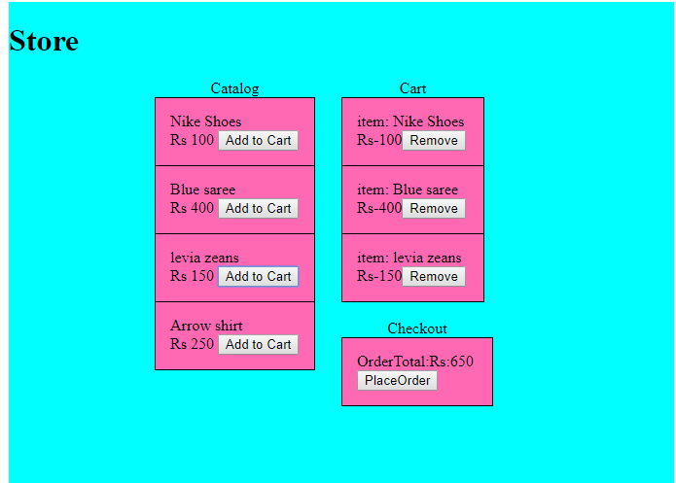

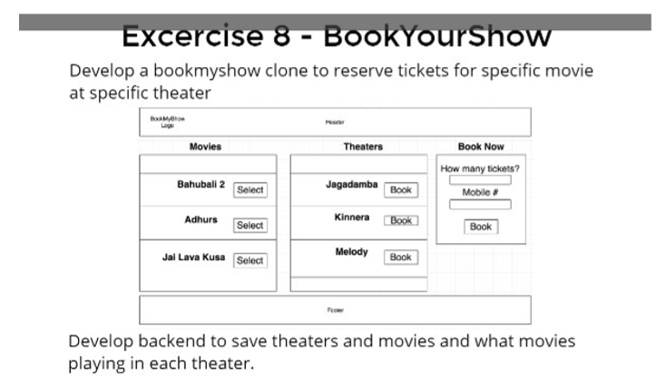

<html>

<body>

<div class="H">

<span>BookMyShow<br><span>Logo</span></span>

<span> Header </span>

</div>

<div class="main">

<div class="left">

<table>

<caption> <b>Movies</b> </caption>

<tr> <td></td> </tr>

<!--<tr> <td> Bahubali 2 &nbsp;&nbsp;&nbsp; <button> Select</button></td> </tr>

<tr> <td>Adhurs &nbsp;&nbsp;&nbsp;&nbsp;&nbsp;&nbsp;&nbsp;&nbsp;&nbsp; <button> Select</button></td> </tr>

<tr> <td> Jai lavakusa &nbsp;&nbsp;<button> Select</button></td> </tr>-->

<tr *ngFor="let show of movie;let i=index">

<td> {{movie[i]}} <button (click)="mov(i)">Select</button></td>

</tr>

<tr> <td></td> </tr>

</table>

</div>

<div class="middle">

<table>

<caption> <b>Theatres</b> </caption>

<tr> <td></td> </tr>

<!--<tr> <td>Jagadamba &nbsp;&nbsp;&nbsp; <button> Book</button></td> </tr>

<tr> <td>Kinnera &nbsp;&nbsp;&nbsp;&nbsp;&nbsp;&nbsp; <button> Book</button></td> </tr>

<tr> <td>Melody &nbsp;&nbsp;&nbsp;&nbsp;<button> Book</button></td> </tr>-->

<tr *ngFor="let show of theater;let i=index">

<td> {{theater[i]}} <button (click)="thea(i)">Book</button></td>

</tr>

<tr> <td></td> </tr>

</table>

</div>

<div class="right">

<table>

<caption> <b>Book Now</b> </caption>

<tr> <td>How many tickets?<br><input type="number" [(ngModel)]="number" required><br>Mobile #<br><input type="text" required><br><br><button (click)="book($event)"> Book </button></td> </tr>

</table>

</div>

<div class="F">

<span> Footer </span>

</div>

<h1>result:</h1><br>

</div>

<table class="out">

<tr><th>movie</th><th>theater</th><th>No.of tickets</th></tr>

<tr *ngFor="let mov of sel">

<td>{{mov.movie}}</td>

<td>{{mov.theater}}</td>

<td>{{mov.nooftick}}</td>

</tr>

</table>

</body>

</html>

import { Component } from '@angular/core';

@Component({

selector: 'app-root',

templateUrl: './app.component.html',

styleUrls: ['./app.component.scss']

})

export class AppComponent {

//title = 'exercise8';

movie=['Bahubali 2','Adhurs','Jai lavakusa'];

theater=['Jagadamba','Kinnera','Melody'];

sel:object[]=[];

tick={};

number:number=0;

mov(i){

this.tick["movie"]=this.movie[i];

}

thea(i){

this.tick["theater"]=this.theater[i];

}

book(){

this.tick["nooftick"]=this.number;

this.sel.push(this.tick);

this.tick={};

if(this.number!=0)

{

alert("movie tickets booked");

}

}

}

span{

margin-right:250px;

}

.H{

border:2px;

border-style:solid;

margin-left:5px;

background-color: rgb(233, 243, 97);

}

table {

border-collapse: collapse;

margin-right:50px;

}

table, th, td {

border: 1px solid black;

padding:20px;

text-align: center;

}

.main{

position:relative;

background:aquamarine;

width:100%;

height: 300px;

min-width:150px;

text-align: center;

display: inline-block;

}

.left{

position:absolute;

top:2px;

left:0px;

height:50px;

width:500px;

text-align: center;

margin-left: 180px;

}

.middle{

height:50px;

width:500px;

margin:0px auto;

text-align: center;

margin-right: 410px;

}

.right{

position:absolute;

top:0px;

right:0px;

width:500px;

text-align: center;

margin-right: 180px;

}

.F{

border:2px;

border-style:solid;

margin-top:250px;

background-color: rgb(245, 104, 245);

height:40px;

text-align: center;

}

.out{

text-align:center;

margin-left: 500px;

}

